**Appendix C: SATIM assumptions**

**Electricity**

Within SATIM, the power sector is split into Generation, Transmission and Distribution. Operating power plants are represented individually and the power sector in SATIM includes the expected decommissioning schedule of coal fired power plants, all planned new builds, planned retrofits as well as plant technology characteristics (efficiency, capacity factors, individual cost components etc).

***Existing capacity***

Capacity values and decommissioning dates are taken from Eskom (2018), NERSA (2018), and the IRP 2019 (DMRE, 2019) reports. Availability for the plants has been taken from table 6 of the IRP 2019 report, combined with data from Eskom CDM webpage Eskom (2018).

Existing power sector capacity and plant availability*

|  |  |  |  |  |  |  |
| --- | --- | --- | --- | --- | --- | --- |
| Station | Type | Capacity (GW)  - 2020 | End of Life | Maximum Availability % | | |
| 2020 | 2025 | 2030 |
| Camden | Coal | 1.481 | 2028 | 57% | 60% | - |
| Grootvlei | Coal | 0.570 | 2022 | 38% | - | - |
| Komati | Coal | 0.205 | 2022 | 35% | - | - |
| Arnot | Coal | 2.232 | 2029 | 55% | 66% | - |
| Duvha | Coal | 2.875 | 2034 | 57% | 61% | 60% |
| Hendrina | Coal | 1.293 | 2026 | 58% | 61% | - |
| Kendal | Coal | 3.840 | 2044 | 77% | 74% | 73% |
| Kriel | Coal | 2.850 | 2030 | 54% | 64% | 64% |
| Lethabo | Coal | 3.558 | 2041 | 64% | 75% | 71% |
| Majuba (dry) | Coal | 1.833 | 2048 | 73% | 77% | 71% |
| Majuba (wet) | Coal | 2.010 | 2051 | 73% | 77% | 71% |
| Matimba | Coal | 3.690 | 2042 | 83% | 78% | 79% |
| Matla | Coal | 3.450 | 2034 | 68% | 71% | 70% |
| Tutuka | Coal | 3.510 | 2041 | 56% | 61% | 58% |
| Kelvin b | Coal | 0.600 | 2027 | 32% | 32% | - |
| Sasol SSF Coal Plant | Coal | 0.600 | post 2050 | 73% | 73% | 73% |
| Sasol Infrachem Coal Plant | Coal | 0.128 | post 2050 | 56% | 56% | 56% |
| OCGT liquid fuels | Diesel | 2.460 | 2040 | 96% | 96% | 96% |
| Hydro - South Africa | Hydro | 0.665 | post 2050 | 12% | 12% | 12% |
| Hydro - Imported | Hydro | 1.500 | post 2050 | 69% | 69% | 69% |
| Koeberg | Nuclear | 1.860 | 2045 | 84% | 84% | 84% |
| Pumped hydro storage | Storage | 1.580 | post 2050 |  |  |  |

The costs for coal supply are defined for each plant and are based on Eskom (2019), since this is not made available in the Integrated Resource Plan.

***Committed new build***

This is capacity that has come online since 2012 and/or is under construction, which includes new coal power, diesel peaker turbines, micro-hydro, pumped hydro, and renewable energy.

Committed new capacity additions (GW)

|  |  |  |  |  |  |  |  |
| --- | --- | --- | --- | --- | --- | --- | --- |
|  | 2012 - 2017 | 2018-19 | 2020 | 2021 | 2022 | 2023 | Total |
| Medupi | 1.44 | 0.72 | 0.72 | 0.72 | - | - | 4.33 |
| Kusile | 0.72 | - | 1.44 | 0.72 | 0.72 | 0.72 | 4.33 |
| Pumped Storage - Ingula | 1.32 | - | - | - | - | - | 1.32 |
| DoE Peakers (Diesel) | 1.01 | - | - | - | - | - | 1.01 |
| Micro hydro | - | - | - | 0.005 | - | - | 0.005 |
| CSP 9 hrs storage | 0.30 | 0.10 | - | - | - | - | 0.50 |
| Solar PV Fixed | 1.92 | - | - | - | - | - | 1.92 |
| Solar PV tracking | 0.51 | - | 0.11 | 0.30 | 0.40 | - | 1.33 |
| Wind | 2.64 | - | 0.24 | 0.30 | 0.82 | - | 4.00 |

Source: DMRE (2019)

Combining the existing stations with the committed new build the total installed capacity in South Africa is 56.82 GW of which 40.5 GW is coal capacity (i.e. 71% of installed capacity).

Total capacity in 2020 (GW)

|  |  |  |  |
| --- | --- | --- | --- |
|  | Committed build by 2020 | Existing | Total |
| Coal | 5.78 | 34.725 | 40.50 |
| Pumped hydro | 1.32 | 1.58 | 2.90 |
| OCGT | 1.01 | 2.46 | 3.47 |
| Hydro (incl. Imported hydro power) | - | 2.165 | 2.17 |
| CSP | 0.50 | 0 | 0.50 |
| Solar PV | 2.55 | 0 | 2.55 |
| Wind | 2.88 | 0 | 2.88 |
| Nuclear | - | 1.86 | 1.86 |
| Total | 14.03 | 42.79 | 56.82 |

The Medupi and Kusile power stations, together representing the largest share of new generation capacity in South Africa, have been reporting low availability factors while technical problems in construction and commissioning are addressed. We that the maximum availability factors rise from 55% and 40% respectively in 2020, to 80% each by 2025. Availability factors for the power stations on the system are taken from DMRE (2019).

Availability of coal stations and Koeberg (excluding proposed IRP coal capacity)

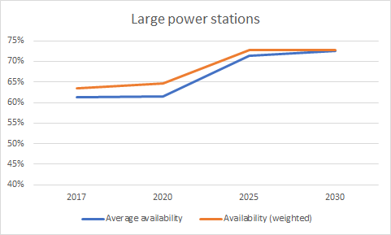

***New build options for SATIM***

The costs for new build options are aligned with the IRP 2019 (DMRE, 2019), based on EPRI (2017), adjusted for inflation and including 10% owner’s development costs. The costs for Medupi and Kusile are updated based on capital expenditure profile in Steyn et al. (2017).

New power capacity build options (DMRE, 2019)

|  |  |  |  |  |  |  |
| --- | --- | --- | --- | --- | --- | --- |
|  | Efficiency | Variable Cost R/GJ | Fixed Cost  Rm/GW/year | Overnight Investment Cost R/kW | Lead time | Plant life |
| Medupi* | 37% | 80.66 | 845 | 36,529 | 6 | 30 |
| Kusile* | 37% | 80.66 | 845 | 36,529 | 6 | 30 |
| Generic supercritical Waterberg Coal Plant | 44% | 80.66 | 933 | 39,335 | 4 | 30 |
| Pumped Storage New Ingula * | 78% |  | 183 | 22,451 | 6 | 50 |
| DOE Peakers* | 31% | 2.41 | 162 | 9,066 | 2 | 30 |
| Fluidised Bed Combustion Coal | 33% | 174.55 | 568 | 46,960 | 4 | 30 |
| Micro hydro* | 100% | 0.00 |  | 11,516 | 2 | 50 |
| Nuclear Mid | 35% | 37.29 | 977 | 68,550 | 9 | 60 |
| Solar Central Receiver 09 hrs storage | 100% | 0.89 |  |  | 3 | 30 |
| Solar PV Fixed | 100% | 0.00 | 270 | See below | 1 | 25 |
| Solar PV tracking | 100% | 0.00 | 286 | See below | 1 | 25 |
| Wind | 100% | 0.00 | 611 | See below | 2 | 20 |
| Inga III | 100% |  |  | 51,227 | 5 | 50 |
| Open Cycle Gas Turbine - LNG | 31% | 2.41 | 162 | 9,066 | 2 | 30 |
| Combined Cycle Gas Turbine - LNG | 49% | 22.06 | 167 | 9,955 | 3 | 30 |
| Gas Engines - LNG | 45% | 70.57 | 425 | 14,144 | 2 | 30 |
| Biomass municipal waste | 45% | 115.14 | 1594 | 18,911 | 3 | 25 |
| Landfill gas | 45% | 62.26 | 1594 | 18,911 | 3 | 25 |

Rand values are for the year 2015.

* Committed new build capacity, for information.

New renewable energy generation plant costs and performance are based on Ireland and Burton (2018). Solar PV and wind technology cost reduction projections for the reference scenario learning can be seen in the figure below, shown in April 2016 ZAR/kWh, model inputs are in January ZAR 2015. National wind and PV temporal energy production profiles and the removal of total resource constraints are based on (DoE REDIS, 2018) and (CSIR, 2016).

Projected levelised costs of electricity from centralised single-axis tracking solar PV and onshore wind from 2015 to 2050

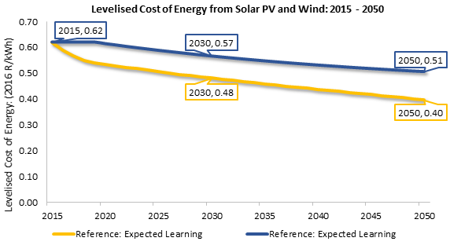

***Solar PV reference scenario technology assumptions***

Annual capacity factors are assumed to be 28% using single-axis tracking solar PV technology, and 25% for fixed-tilt. This is based on existing South African plant performance, using historical hourly production data from 2015-2017 (DoE REDIS, 2018). Plant life is 25 years, and construction time 1 year. The earliest date for new centralised solar PV capacity to come online is assumed to be 2023.

Plant cost and performance parameters are modelled to start at calculated 2015 Round 4-expedited REIPPPP values, and improve, using adapted projected rates of change according to the National Renewable Energy Laboratory (NREL) Annual Technology Baseline (NREL ATB, 2018).

*Onshore wind reference scenario technology assumptions*

Annual capacity factors for new onshore wind farms are assumed to start at 36% for plants of size 100MW+ (DoE REDIS, 2018). This increases to 43% in 2050. Plant life is 20 years, and construction time 2 years. The earliest date for new wind capacity to come online is assumed to be 2024.

Plant cost and performance parameters are modelled to start at calculated 2015 REIPPPP values and change using adapted projected rates of improvement according to the NREL Annual Technology Baseline (NREL ATB, 2018), and IEA Wind (2018).

New renewables and battery storage overnight investment cost and capacity factor

|  |  |  |  |  |  |  |  |
| --- | --- | --- | --- | --- | --- | --- | --- |
| Technology | Annual Capacity factor | Cost in Rm/GW | | | | | |
| 2017 | 2020 | 2025 | 2030 | 2040 | 2050 |
| Solar Central Receiver 09 hrs storage | 47% | 57,809 | 52,631 | 43,999 | 35,368 | 35,368 | 35,368 |
| Solar PV Fixed | 25% | 12,570 | 8,900 | 8,355 | 7,849 | 6,973 | 6,160 |
| Solar PV tracking | 28% | 14,788 | 10,471 | 9,829 | 9,234 | 8,203 | 7,247 |
| Wind | 36% (2020) - 43% (2050) | 15,313 | 12,500 | 12,286 | 12,126 | 11,966 | 11,859 |
| Utility Scale Storage - 4hrs | NA | 27,165 | 20,310 | 14,179 | 9,963 | 9,197 | 9,197 |
| Solar PV rooftop (Commercial) | 20% | 14,581 | 10,324 | 9,691 | 9,105 | 8,088 | 7,146 |
| Solar PV rooftop (Residential) | 20% | 21,997 | 15,576 | 14,621 | 13,736 | 12,202 | 10,780 |
| Solar PV rooftop (Industry) | 20% | 14,581 | 10,324 | 9,691 | 9,105 | 8,088 | 7,146 |

Utility scale storage costs and performance are based on multiple sources as described in ESRG (2019) and are modelled as lithium-ion batteries with 4 hours of storage, 89% round-trip efficiency, 15 year operating life, and fixed maintenance cost of 0.6% of CAPEX per year.

***Additional power sector constraints and assumptions***

A 15% firm reserve margin is imposed for the grid from 2025, i.e. the installed dispatchable capacity must be at least 15% higher than the expected peak demand to account for plant maintenance, breakdowns, or periods of higher than expected demand, in line with global norms and work by the CSIR (2020).

We conservatively assume that variable renewable energy cannot contribute to meeting peak demand. Wind and solar generators are modelled to be fully backed up by dispatchable generation or storage regardless whether their profiles may contribute during peak times (i.e. a 0% capacity credit is used). Battery storage is modelled to have only 70% of their capacity contributing to the reserve margin constraint to account for the potential of extended periods of low national wind and solar generation.

It is assumed that for all coal-fired power plants there is a 40% minimum utilisation of capacity for it to be available to contribute to the peak demand reserve margin, and stay online in the system and not be decommissioned.

In SATIM the centralised bulk electricity transmission system is modelled as a single node and sized to meet the projected peak electrical demand in each year. The cost of replacement and additional transmission lines and transformers are costed as a single R/kWpeak value based on Eskom integrated annual reports (9700 R/kW) and central transmission energy losses are set according to Eskom integrated reports [2]. Additional “deep grid strengthening” costs (such as RE collector stations) are added for the total generating capacity which exceeds the peak transmission system capacity able to meet peak demand (2000R/kW) - these costs are aligned with Eskom work done for the IRP 2018/19 (Eskom, 2017).

Distribution systems are sized and invested in within each economic sector to meet their respective peak demands. Their costs are based on the split of costs for Eskom scaled up by the distribution capacity of Metros. The historical capital repayment costs and maintenance costs are calibrated to Eskom reported costs and values observed in the Social accounting matrix for 2012. A different distribution cost (and losses) apply to different sectors. Lower voltage Residential sector grid costs are more labour and equipment intensive and so are more expensive. Distribution system energy losses, technical and non-technical (i.e. theft), are modelled on aggregate per sector and aligned with NERSA (2012).

***New renewable generation build limits***

In the base dataset for SATIM (i.e without a specific scenario affecting RE build rates) an upper limit on the build rate is applied to wind power of 1GW per year starting in 2020 and ramping up gradually to 2GW by 2025, 3GW by 2030 and finally 4GW per year by 2040.

For solar PV, these rates are applied as well, however, it is assumed that solar PV can be rolled out faster in the early 2020’s - with 2GW per year assumed starting from 2020, 2.5GW by 2025, 3GW in 2030, and 4GW in 2040 and thereafter.. These build rates are also applied equally to rooftop PV in residential, commercial, and industrial rooftop PV each at 1 GW/year in 2020, 2GW/year in 2025, 3GW/year in 2030 onward.

Note that different scenarios may include adjusted build rates for RE technologies which are explained in their respective scenario descriptions.

***Additional reliability constraints and assumptions***

Variable wind and solar power production need to be complemented with effective storage capacity or flexible generation. In this methodology, an assumption on utilisation of storage, and gas technologies is used to provide effective backup to large scales of renewables on the grid.

Gas turbines, and diesel peakers, are required to provide at least 8% of the total generation from wind and solar power. This is set conservatively using an indicative “worst case scenario” of an optimised electricity system in South Africa fully supplied by wind, solar, flexible gas, and battery storage of a full year in 2050 using hourly renewable production and demand profiles to test the flexibility and backup requirements needed for a system with 90%+ variable renewable electricity supply.

The power sector build plan results will be validated further using the high resolution IRENA FlexTool (IRENA, 2018) to ensure that sufficient flexible dispatchable capacity is available at all times to ensure adequacy and reliability of the suggested build plans from SATIM. The minimum requirements for additional flexible generation or storage will be adjusted based on this validation.

**Transport**

The transport sector in SATIM includes energy used for passenger and freight transport by road, rail. It also includes energy used in pipeline transfers, aviation and a general “other” sector (incorporating maritime fuel use). Energy demand for passenger and freight transport is driven primarily by two factors, a) vehicle-kilometers travelled and b) the efficiency of travel. The vehicle‐ kilometers travelled are driven by the needs of society and the economy to move people and goods around. Conversion efficiency differs with vehicle type, fuel type and the age of the vehicle parc and to some degree the patterns of utilisation of different vehicle types as described by Stone et al. (2018) and Ahjum et al. (2018).

Aspects of transport included in the parc model are the size of the existing vehicle fleet, annual vehicle sales, annual vehicle scrapping, distance travelled per vehicle, fuel sales and vehicle fuel efficiency. Outputs of the vehicle parc model are total kilometres travelled, the average age of vehicles in the vehicle fleet and the average efficiency of the vehicle fleet. These components allow efficiency or intensity of transport to change with vehicle stock changes and an increase or decrease in vehicle ownership in response to population and income changes.

Certain factors affecting the distance travelled and fuel efficiency, for instance traffic congestion, are difficult to quantify as they are not well understood. To accommodate the unknown impact of tangible and intangible influences on efficiency, the vehicle parc model is calibrated by adjusting variables such as vehicle occupancy and ownership assumptions until the output (annual distance travelled by vehicles) in combination with vehicle fuel efficiency matches known fuel sales data. The annual distance travelled by vehicles is translated into a demand for pkm by assuming average occupancy rates for the different vehicle types in SATIM.

The energy service demand in SATIM is defined in terms of passenger kilometres and tonne kilometres. The ownership of passenger cars in the passenger demand projection model is split between three income groups and a miscellaneous category to accommodate commercially- and government owned cars. With population projections for each of the income groups, the passenger demand projection model uses assumptions around private vehicle ownership by income group, vehicle mileage, vehicle occupancy, public mode shares, average mode speeds, and a travel time budget to derive vehicle-km demand by passenger vehicle class for households. This is combined with a transport-GDP linked projection of the non-household owned cars to give a total passenger vehicle-km demand projection for road vehicles. The passenger-km projections by rail are derived from assumptions around future mode shares. The freight demand projection model takes sector GDP projections and, based on assumptions around load factors and mode shares, makes projections of vehicle-km for different freight vehicle classes. The projections for ton-km are derived from assumptions around future mode shares. Vehicle-km projections for road vehicles are then exogenously imposed in SATIM, which is used to project the least-cost technology and fuel mix to meet the projected vehicle-km demand.

Overview of the SATIM transport sector model (Merven et al. 2012)

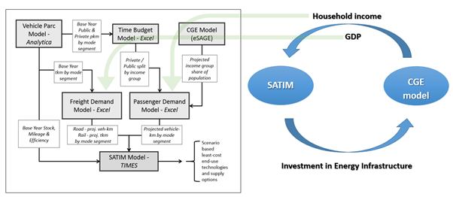

Schematic representation of the vehicle parc mode, data inputs and validations[1]

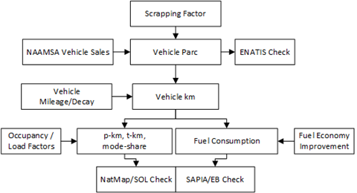

Transport Classes, Technologies and Fuels represented in the SATIM model

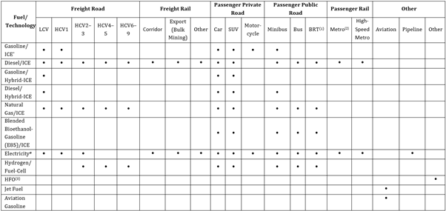

*(1): BRT: Bus Rapid Transport; (2): Metro: Metropolitan i.e. intra‐city; (3): Used for Coastal & Inland Navigation; * Internal Combustion Engine; #: Battery Electric for Road Vehicles; HCV1: Medium commercial vehicle of 3 000–7 500kg GVM; HCV 2: Heavy commercial vehicle of 7 501–12 000 kg GVM; HCV 6: Heavy commercial vehicle of 24 001–32 000 kg GVM. SUV: Sport Utility Vehicle (usually 4X4 and >1ton in mass)*

***Calibration Year 2017***

Subsequent to the release of the draft national inventory 2017 (DEFF, 2020), the SATIM transport model has been refreshed, conforming to the calibration method described, incorporating recent data for the year 2017 to allow for a more robust comparative analysis of the NIR 2017. Key modelling updates and their assumption about transport fuels are described.

***Aviation, Pipelines and ‘Other’***

These transport categories are not disaggregated further and do not have a technology representation. Fuel demand rather than service demand is instead directly correlated to GDP growth. Aviation is further distinguished by International and Domestic demand. The SATIM representation of aviation and maritime fuel usage has previously been informed by DMRE published data. The 2017 SATIM data for these sectors reflect the recent 2018 DEFF Fuel Consumption Study (FCS). Pipeline activity, in contrast, is currently based on historical trends as reported by Transnet (2019).

***Road Transport: Gasoline (Petrol) and Diesel***

The 2017 SATIM revision notably departs from the NIR2017 which reflects the 2018 DEFF FCS for road transport fuels. The 2018 FCS which relies on a method that utlises national and municipal estimates of Vehicle Kilometres Travelled (VKT) and assumptions of activity by vehicle class; reports higher fuel sales volumes than reported by DMRE and SAPIA. It was therefore decided, in consultation with DEFF, to proceed with the previous SATIM calibration method described in the above section. The 2017 revision, as before, attributes ~100% of DoE and SAPIA consumption volumes for gasoline to road transport. With reference to the SATIM energy balance (2017), diesel fuel is however more widely used across other sectors. Of the total reported volume consumed domestically (DMRE 2018). The share of transport diesel is derived from the 2016 DEA FCS for which fuel sales data was extended from 2015 to 2017. The method chiefly relies on assumptions of shares of sales by trade category (by magisterial district) that is presumed to be for road transport. The diesel sales shares assumed in SATIM are taken from the GIZ 2015 coefficients as listed below. Of note, diesel usage by Eskom is accounted for in the aggregate volumes prior to the disaggregation by sector (Eskom 2019).

Comparison of sources for road transport share of total diesel sales for SAPIA trade categories

|  |  |  |  |
| --- | --- | --- | --- |
| Magisterial Trade Category | SATIM 2017; GIZ 2015 Coeff.; DEA (2016) | ERC 2012 Coeff.  Merven et al. (2012) | Stone (2001) |
| Agricultural Co-ops | 30% | 0% | 50% |
| Construction | 0% | 0% | 90% |
| Farmers | 30% | 0% | 50% |
| General Dealers | 100% | 100% | 100% |
| Government | 100% | 0% | 100% |
| Independant LPG Marketers | 100% | 100% | 0% |
| Local Authorities | 80% | 100% | 100% |
| Local marine fishing | 0% | 0% | 50% |
| Mining | 0% | 0% | 70% |
| Public Transport (by local Auths) | 100% | 100% | 100% |
| Public Transport (non local Auths) | 100% | 100% | 100% |
| Remainder of General Trade | 90% | 100% | 100% |
| Retail - garages | 100% | 100% | 100% |
| Road Haulage | 100% | 100% | 100% |
| Transnet | 0% | 100% | 0% |

Key transport fuels and their data sources, and Fuel demand in Transport are summarised below.

Key model parameters and data sources

|  |  |  |
| --- | --- | --- |
| Model Parameter | Attribute | Source |
| Road Transport | Diesel | DMRE; SAPIA |
| Road Transport | Gasoline | DMRE; SAPIA |
| Road Vehicle Population | Existing population: Private; Public; Freight | NAAMSA; e-Natis |
| Freight Rail | Diesel, Electricity | Transnet |
| Pipelines | Electricity | Transnet |
| Water Borne Navigation | HFO | DEFF FCS (2018)1 |
| Aviation (Domestic & Foreign) | Jet Fuel | DEFF FCS (2018) |

*1DEFF Fuel Consumption Study (2018)*

Fuel demand in Transport for 2017

|  |  |  |
| --- | --- | --- |
| Fuel | Demand (TJ) | Source |
| Gasoline | 382,151 | SAPIA |
| Diesel | 341,081 | UCT from DEA FCS (2016) |
| Electricity | 12,535 | StatsSA (SUT)1; Transnet |
| Jet Fuel Domestic Aviation | 20,465 | DEFF FCS (2018) |
| Jet Fuel International Aviation | 68,939 | DEFF FCS (2018) |
| HFO – Domestic Maritime | 4,509 | DEFF FCS (2018) |
| HFO – International Maritime | 21,947 | DEFF FCS (2018) |

*1SUT: Supply and Use Tables (derived from Rand value)*

**Residential**

Residential sector energy demand in SATIM is based on a demand for household energy services, which is driven by population growth and household income. In 2017, the population was 55.6 million, increasing to 62.8 million in 2030 and 75.2 million in 2050. The estimated number of households in 2017 is 17.4 million, of which 84.7% are assumed to be electrified.

Households are split into low, middle- and high-income household groups. This is done to capture both the shift in fuel use as household income rises as well as increases in appliance ownership and the corresponding increase in energy use (MJ/household) as income rises.The low, middle- and high-income groups correspond to a mean income of around R37000, R85 000 and R 530 000 respectively. In 2017, 48.5 percent of households fell in the low-income group, 31.5 percent were in the middle income group and 20 percent were in the highest income group.

All household income groups are assumed to use energy for cooking, lighting, space heating and cooling, water heating, refrigeration and for “other” uses, such as television, and clothes washing. “Other”, refrigeration and lighting in the high-income groups are distinct from all other energy services in that they are only met by electrical appliances. Lighting in the low- and middle-income groups is met by paraffin and electricity, however the use of electricity dominates consumption. Households in the low- and middle-income groups use a range of fuels for water heating, space heating and cooking, these are electricity, wood, coal, paraffin and gas. The percentage of households using each fuel for water heating, space heating and cooking is calibrated using StatsSA data from the 2016 community survey and 2011 Census.

The total energy use assigned to households in 2017 is provided in the table below. The energy consumption attributed to households in the GHG Inventory is also shown in the table. There is a large difference in coal use, between the Inventory and the Fuel use Study. According to the 2016 Community Survey, roughly three percent of households use coal (fewer than 2% use coal as a main fuel). The 2011 Census also reports that less than two percent households use coal as their main fuel for either cooking or space heating. Assuming that 520 thousand households used coal in 2017, the fuel use study is in line with a daily consumption of coal of 3.4 kg a day, whereas the Inventory estimate would require these households to use around 63 kg a day.

Fuel consumption in the Residential sector

|  |  |  |  |  |  |
| --- | --- | --- | --- | --- | --- |
| Total (PJ) | Electricity | Paraffin | Gas | Wood | Coal |
| NDC update | 172.33 | 9.64 | 17.98 | 83.77 | 15.62 |
| DEFF inventory |  | 9.64 | 17.98 | 83.77 | 294.42 |
| DEFF Fuel use study |  |  |  |  | 15.62 |

The allocation of fuel used in income groups is shown below. The figure shows both the movement away from solid fuels towards electricity and gas as income rises, as well as the far higher use of electricity in higher income households compared to the other household groups. It is clear that a large increase in average household income would translate to a large increase in electricity consumption in the residential sector. Any policies aimed at improving the efficiency of electrical appliances will therefore also have the greatest impact on electricity consumption in the high-income group.

Energy use in the residential sector

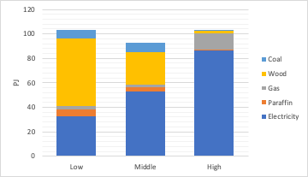

The relative share of fuels supplying each energy service is shown in the two figures below with the difference, reflecting the efficiency at which energy services are delivered by different fuels.

The relative share of fuels supplying energy services in the residential sector

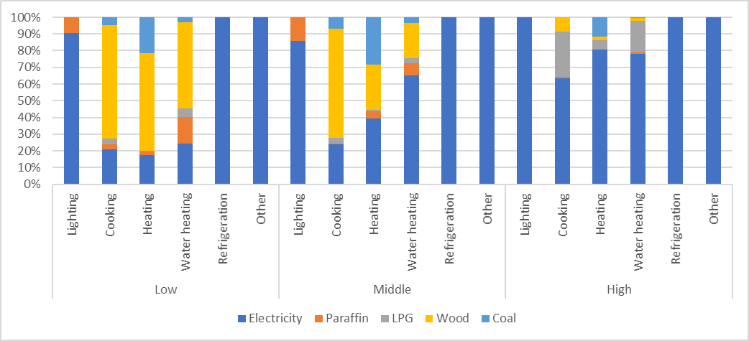

The relative share of energy services delivered by fuel in the residential sector

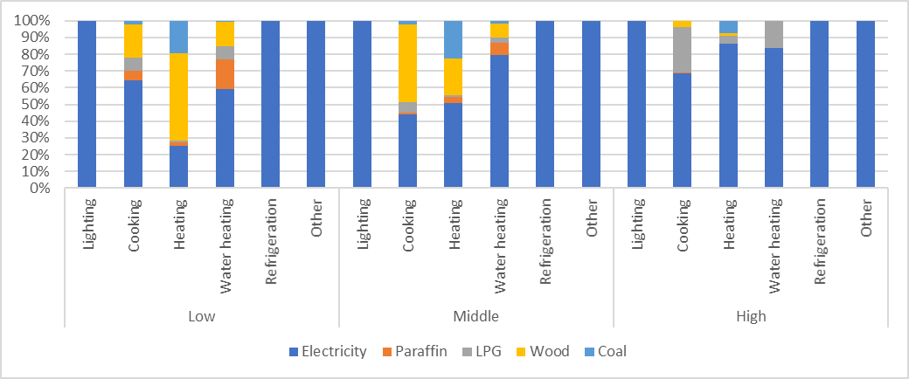

In the residential sector the relative share of each fuel supplying energy services, as well as the efficiency at which households derive energy services, changes over time. There are two primary shifts occurring that drive the relative share of fuel supplying energy services. Firstly, the share of households in income groups changes as GDP grows or shrinks. With growing GDP, this shift is primarily households moving into the higher income group from the middle-income group and households transitioning from the lower income group to the middle-income group. It has the effect of increasing the amount of energy consumed by the sector as well as the fuels used to supply energy services. In addition, the electrification rate is assumed to continue to increase over time. This has the effect of increasing electricity consumption relative to the consumption of other fuels in each income group as it is assumed that electrified households will use energy similarly to those already electrified in the income group.

The efficiency of refrigerators and other appliances is assumed to increase over time. The share of solar water heaters and heat pumps rises, particularly in high income households, as does the share of efficient lights, particularly LEDs. In the reference case the increase in efficiency is modest and is assumed to be primarily driven by the MEPS and Standards and Labelling programmes. A modest 13% efficiency improvement by 2030 is assumed across all income groups, but this is not applied to all fuels and energy services. For cooking, it is applied to electric hot plates and stoves, biomass, and coal use; and for water heating, to electric geysers. It is applied to all refrigeration and other electric appliances.

**Industry**

The industrial sector in SATIM consists of several energy intensive sectors, such as the iron and steel and Aluminium sectors, and the less energy intensive but more numerous producers such as the food and beverages or general manufacturing industries.

In SATIM, two methodologies are applied to model either of these industrial sectors. The first method (methodology one) relies on estimates of *energy service* requirements for cooling, compressed air, lighting, or process heat etc., the second method (methodology two) utilises an estimate of the *energy intensity* of industrial technology processes. Method two is typically applied to sectors where products are more uniform, and the energy intensity of production is high like iron and steel.

Methodology one is applied to the mining, chemicals, food beverages and tobacco, precious and non-ferrous metals (excluding aluminium) and general manufacturing. In this approach an estimate of the total useful energy service requirement (e.g. Process heat, compressed air, etc), per unit of output, and the efficiency at which energy services are met are exogenously specified and allow the model to endogenously determine final energy consumption for each energy service in the sub-sector. The driver of industrial energy consumption is therefore the demand for useful energy services. This is demonstrated below, where the level of useful energy services needed, in this case process heating, and the efficiency of the boiler, determines the amount of final energy (coal) consumed.

Methodology 1 example of representing energy service requirements in industry

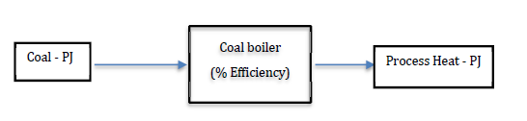

Methodology two is used for the Iron and Steel, Ferroalloys, Aluminium, Non-metallic minerals (Cement, Glass, Lime, and brick), and pulp and paper sectors. The demand for final energy in these sectors is calculated endogenously based on the energy intensities specific to technology processes and their level of production (tonnes of steel produced etc.). For example, in the figure below, the demand for coal and coke by blast furnaces in the production of iron is calculated based on the technology specific energy intensity (GJ/t) of iron production in South African blast furnaces. To apply methodology two, the share of production by technology type and the energy intensity of production in South Africa must be known or estimated[2].

Methodology 2 example of representation of energy intensive industries

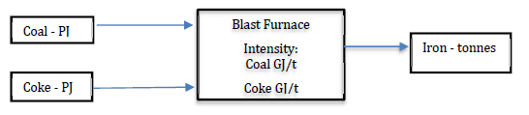

***Energy services for methodology 1 sectors***

Split of end-use electricity consumption by subsectors for methodology one (EIA, nd)

|  |  |  |  |  |  |
| --- | --- | --- | --- | --- | --- |
|  | Mining | Chemicals | Non-ferrous metals | Food & Bev | Other |
| Electric Heating | 2% | 2% | 1% | 7% | 10% |
| Compressed air | 19% | 15% | 0% | 4% | 11% |
| Lighting | 5% | 4% | 1% | 5% | 8% |
| Cooling | 8% | 5% | 0% | 23% | 5% |
| HVAC | 8% | 2% | 1% | 6% | 8% |
| Pumping | 18% | 35% | 0% | 28% | 13% |
| Fans | 7% | 8% | 0% | 4% | 6% |
| Other motive | 34% | 20% | 7% | 21% | 37% |
| Electrochemical | 0% | 8% | 90% | 0% | 1% |
| boiler/process heating | 0% | 1% | 0% | 2% | 1% |
| Total | 100% | 100% | 100% | 100% | 100% |

Electricity end use shares by sector

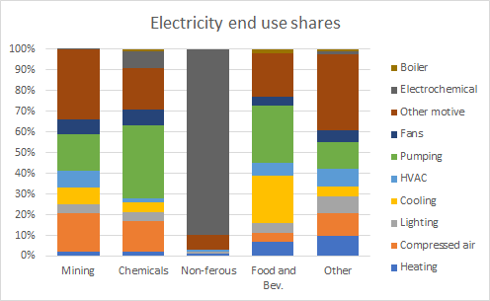

For thermal fuels such as coal, gas, and LPG, these are assumed to be used in boilers in these sectors, producing process heat.

The methodology two subsectors each have more detailed representation of energy flows and technologies to represent the major components of industrial systems for example the clinker kilns in the cement manufacturing route or the boilers for steam in the Pulp and Paper sector. The figure below gives the basic overview of these sectors.

Schematic of methodology 2 industrial sectors (Iron & Steel, Cement, Pulp & Paper, Ferroalloys)

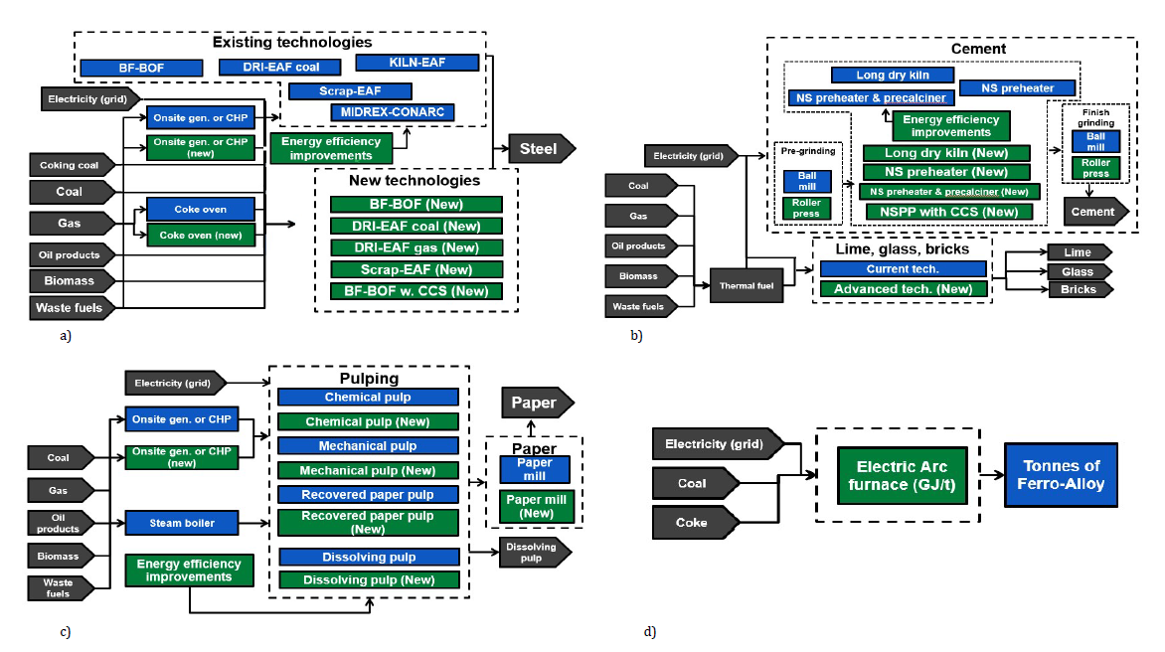

Energy consumption and calibration for the industrial subsectors in SATIM is calculated using known and estimated energy use from the energy balance and from company or industrial association reports available publicly for the methodology 2 sectors, and from stakeholder engagement.

***Iron and Steel***

South Africa has about 10Mt of crude steel capacity, much of which is under-utilised or even moth balled as of 2020 with just 6.13Mt being produced in 2019 (WSA).

The major player of steel production in South Africa is ArcelorMittal South Africa (AMSA), with a few independent scrap metal companies. AMSA produces iron from iron ore. EVRAZ Highveld historically produced virgin steel but closed in 2015 due to financial problems. It is reported some of the steel milling parts of the facilities are still being used as of 2020, but no production of virgin steel is taking place.

Saldanha facility is a world unique combination of iron producing furnaces with lower material (coke) requirements in a combination of COREX and MIDREX technologies. The facility was an export market-based production site - being located at the Saldanha port but closed down in 2020 due to financial reasons.

A picture of capacity and production from the steel production routes for South Africa is derived based on annual reports by World Steel Association [WSA], and ArcelorMittal South Africa integrated reports [AMSA], and a variety of news articles pertaining to the operations of the major facilities.

Process routes description of the Iron and Steel sector in SATIM

* DRI-EAF - Direct Reduced Iron to Electric Arc furnace
* BF-BOF - Blast Furnace to Basic Oxygen Furnace
* Corex - Conarc - Saldanha facility hosting a Corex, Midrex, an EAF and BOF
* Other - Evraz Highveld

Steel production volumes and process route in South Africa (Mt/year)

|  |  |  |  |  |  |  |  |  |  |
| --- | --- | --- | --- | --- | --- | --- | --- | --- | --- |
|  | 2012 | 2013 | 2014 | 2015 | 2016 | 2017 | 2018 | 2019 | 2020* |
| BF-BOF | 3.30 | 3.38 | 3.09 | 3.16 | 3.16 | 3.03 | 3.20 | 3.03 | 3.03 |
| Corex-Conarc | 1.21 | 1.24 | 1.13 | 0.96 | 0.83 | 1.12 | 1.09 | 1.09 | - |
| DRI-EAF | 0.95 | 0.97 | 0.89 | 0.77 | 0.77 | 0.76 | 0.80 | 0.80 | 0.76 |
| Other-EAF | 0.62 | 0.63 | 0.58 | 0.14 | - | - | - | - | - |
| Scrap-EAF | 0.86 | 0.88 | 0.81 | 1.36 | 1.32 | 1.32 | 1.21 | 1.21 | 1.21 |
| Total | 6.94 | 7.10 | 6.50 | 6.40 | 6.09 | 6.23 | 6.30 | 6.13 | 5.00 |

*\*estimate based on 2019 figures with Saldanha closing*

The scrap ratio is the amount of steel being produced via scrap-EAF route in this methodology. This was estimated based on the amount of steel being produced that does not come from an iron ore production route like the BF or DRI. This is an estimate of 1.2Mt out of 6.13Mt in 2019.

Energy intensity of the process routes is adapted from Worrel et al. (2008), combined with the energy balance used to calibrate SATIM, company reports (AMSA, 2018), and Scholtz et. al. (2006).

Energy intensity of steel process routes (GJ/t steel produced)

|  |  |  |  |  |  |  |
| --- | --- | --- | --- | --- | --- | --- |
|  | Coal Bit | Electricity | Coke | LPG | Natural Gas | Total GJ/t |
| BF-BOF | 4.33 | 2.10 | 8.88 | 0.59 | 0.53 | 16.43 |
| DR-EAF | 20.60 | 4.86 | - | - | 2.29 | 27.74 |
| SCRAP-EAF | - | 4.09 | - | 0.71 | 0.69 | 5.49 |
| COREX-CONARC | 17.20 | 1.73 | 2.60 | 0.22 | 0.41 | 22.15 |
| Other | 20.61 | 20.61 |  |  | 3.44 | 44.66 |

*New build options*

For each process route, there is a new build option available for model optimisation, with the same parameterisation in energy and costs as existing options. Costs are based on IEA (2010).

An additional new option for steel production based on hydrogen Direct Reduced Iron to Electric Arc Furnace for steel production. Instead of coal and/or coke being used as the reducing agent for iron ore in the furnace, it is replaced with hydrogen. The gaseous products are water vapour which can be recycled through an electrolyser. This is based on Vogl et. al. (2018). Data for the electrolyser, in this setup a Platinum based PEM electrolyser, is taken from IEA (2019). Storage of hydrogen is included in SATIM for this process as a simple energy storage technology, and no costs are associated with this component as according to the IEA (2019) hydrogen storage is not a major cost burden if it is located at the source of hydrogen production (electrolyser) and is used onsite as well. Most of the costs in hydrogen storage are associated with the actual transportation part of the cycle - compressing, liquifying or transforming of hydrogen for transport to a different location.

Hydrogen Direct Reduction of Iron for steel production

|  |  |  |
| --- | --- | --- |
|  | 2030 | 2050 |
| PEM Electrolyser | | |
| CAPEX - mR/GWe | 18,480 | 11,088 |
| Efficiency - % | 63% | 67% |
| lifespan - hours | 60000 | 75000 |
|  |  |  |
| Direct Reduction Furnace | | |
| CAPEX - mR/Mt | 3,000.89 | 3,000.89 |
| Labour cost - mR/Mt | 619 | 619 |
| Input H2 - PJ H2 per Mt | 6.12 | 6.12 |
| Input ore - Mt Ore per Mt | 1.504 | 1.504 |
|  |  |  |
| Electric Arc Furnace (EAF) | | |
| CAPEX - mR/Mt | 2,606.89 | 2,606.89 |
| Labour | 619 | 619 |
| Input - Electricity PJ/Mt | 2.711 | 2.711 |

Industrial Processes and Product Use (IPPU) emission factors for the iron and steel sector are taken from the IPCC guidelines for iron, and steel production for each technology and grouped for each process route (eg. BF-BOF includes BF and BOF factors). These combinations are given in the table below. The Saldanha (Corex-Conarc) route is a combination of a 50/50 split on steel route for BOF and EAF, and the iron production (Corex and Midrex) which is based on relative output proportions of those technologies (AMSA_1) with a 10% ‘efficiency’ adjustment for the Corex (as an efficient BF) component and using standard IPCC guides. Emissions for the hydrogen based DRI route are equated to that of the ‘scrap-EAF’ route.

IPPU emissions factors for Iron and Steel sector in SATIM

|  |  |
| --- | --- |
|  | Tonne CO2/tonne steel output |
| BF-BOF | 2.81 |
| DRI-EAF | 1.61 |
| Scrap-EAF | 0.08 |
| Corex-Conarc | 2.12 |
| Other-EAF | 1.54 |

Coke production emissions resulting in IPPU emissions are taken from IPCC guidelines of 0.52 t CO2/t coke, with 30 MJ/kg assumption for coke gives 17.3 t CO2/TJ coke produced.

***FerroAlloys***

South Africa is rich in chromite and manganese ores and has a well-established Ferrochrome and Manganese industry. South Africa is the largest exporter of Ferrochrome, and the second largest producer in the world (DMR, 2019). Most of the ferro-alloy production in South Africa is in the form of ferrochrome - at about 3.3 Mt in 2017.

Production (tonnes) of ferro-alloys in South Africa. Source: DEFF 2020b

|  |  |  |  |
| --- | --- | --- | --- |
|  | 2015 | 2016 | 2017 |
| FerroChrome | 3,685,000 | 3,334,706 | 3,370,941 |
| FerroManganese | 615,000 | 847,156 | 862,616 |
| FerroSilicon | 180,600 | 144,200 | 139,197 |
| Total | 4,480,600 | 4,326,061 | 4,372,754 |

Due to lack of data available, in this methodology the three alloys are grouped together as one technology which includes pre-reducing through to smelting phase. The energy inputs based on the energy balance and the studies by Lagendijk et.al. (2010), and Biermann et. al (2012) are used to calibrate this technology for the total production of 4.3Mt of FerroAlloys for 2017. Below are the energy intensity values used to estimate this grouping:

Energy Intensity (GJ/t product)

|  |  |  |  |
| --- | --- | --- | --- |
|  | Coal | Coke | Electricity |
| Chrome | 17.98 | 9.90 | 14.04 |
| Manganese | 10.91 | 9.44 | 8.28 |
| Ferrosilicon | 10.91 | 9.44 | 8.28 |
| Weighted avg. | 16.36 | 9.80 | 11.87* |

*\* Adjusted for calibration to the energy balance*

*Emissions*

Process emissions from ferroalloys (FA) production are adopted from DEFF (2020), based on IPCC emissions factors, and are grouped in SATIM for the single ferroalloys technology:

Process emissions for ferro alloys in SATIM

|  |  |  |
| --- | --- | --- |
|  | t CO2/tonne FA | kg CH4/tonne FA |
| FerroChrome | 3.2 | 0 |
| Ferromanganese | 1.3 | 0 |
| FerroSilicon | 3.6 | 1 |
| Weighted total | 2.88 | 0.03 |

No new technology build options are assumed in this methodology. The change in the consumption of energy, and production of emissions arising from a change in the demand for ferroalloys (driven by GVA factors).

***Aluminium***

South Africa has one aluminium producing facility in Richards Bay. All the alumina is imported as there is no alumina production in South Africa.

A total of 806 kt of primary and secondary aluminium was produced in 2017, with the primary production making up most of the production and energy consumption.

In SATIM this is represented with a single node/technology with a total of 53 GJ per tonne of aluminium as the energy intensity. Electricity is the main source of energy for reducing alumina to aluminium using carbon anodes in this process.

Process emissions factors for this technology are taken from the IPCC guidelines (as adopted in the National Emissions Inventory) (DEFF, 2020), they are given below:

|  |  |
| --- | --- |
| GHG | tonnes GHG per kt product |
| CO2 | 1641 |
| CF4 | 0.410 |
| CF6 | 0.041 |

It is assumed that production of aluminium is constant through the modelling period. No new build options are available for this technology.

***Non-metallic-minerals: Cement***

The cement manufacturing process has been divided into three stages:

* Pre-grinding
* Clinker kiln
* Blending

For the pre-grinding and blending stages two technologies were modeled: The less efficient Ball Mill and the more efficient Roller Press. Three kiln types have been modeled: 1) The older, less efficient Long Dry Kiln, 2) New suspension rotary kiln with preheater and 3) New suspension rotary kiln with preheater and pre-calciner. The new build technology assumes that the existing capacity is replaced with entirely new plant built at best available technology (considering South Africa-specific limitations).

*Installed capacity*

Installed capacity of current technologies was determined based on input from the industry and consultation of industry websites. These were then aggregated into the different kiln types. A 95% annual availability for all plants was assumed.

The table below gives the total installed capacity for cement kilns and mills for this representation in SATIM along with the energy intensity of the processes. For energy intensities, Napp’s work was the basis for this representation, and was originally based on energy intensities of the different technologies according to values obtained from the literature (EU commission 2010, Worrel et al. 2000, 2001). These had since been updated and adjusted against the energy balance calibration efforts (see section Energy balance).

The energy supply to both the pre-grinding and blending stages was assumed to be 100% electricity. For the kilns, a share of electricity and thermal fuel is supplied. Thermal fuel was assumed to be a mix of coal, natural gas, and fuel oil with coal making up the majority of the input at 71% and gas the remaining. It is known that industry is using solid waste in the form of things like used car tires, but owing to lack of information this is not represented. Biomass is an option as well, but this is set to zero initially, and assumed it can make up at most 20% of maximum thermal fuel requirements.

Cement production technologies, capacities and energy intensities

|  |  |  |  |  |  |  |  |  |  |  |  |
| --- | --- | --- | --- | --- | --- | --- | --- | --- | --- | --- | --- |
|  |  | Existing Technologies | | | | | | | New build technologies | | |
|  |  | Pregrinding-crushing | | Kiln | | | Finish grinding | | Kiln | | |
| Inputs | Unit | Ball mill | Roller press | Long dry kiln | NSPreheater | Nspreheater, precalciner | Ball mill | Roller press | NSPreheater | Nspreheater, precalciner |
| Current Installed Capacity | Mt | 6.6 | 4.1 | 0.8 | 7.4 | 2.5 | 9.2 | 5.6 |  |  |
| Availability | - | 0.95 | 0.95 | 0.95 | 0.95 | 0.95 | 0.95 | 0.95 | 0.95 | 0.95 |
| Energy intensity (2017) | GJ/t | 0.079 | 0.059 | 4.2 | 3.4 | 3.1 | 0.2 | 0.13 |  |  |
| New build energy intensity) | GJ/t |  |  |  |  |  |  |  | 3.20 | 3.00 |
| Fuel mix shares | | | | | | | | | | | |
| Thermal fuel | - | 0 | 0 | 0.98 | 0.98 | 0.97 | 0 | 0 | 0.98 | 0.97 |
| Electricity | - | 1 | 1 | 0.02 | 0.02 | 0.03 | 1 | 1 | 0.02 | 0.03 |
| Costs | | | | | | | | | | | |
| Installation cost | 2015 R/t |  | 36.4 |  |  |  |  | 27.5 | 2520 | 2853 |

The production of cement in South Africa amounted to about 14.8Mt in 2017 with the clinker ratio at 69% (DEFF, 2020).

Tonnes of cement, and clinker production (DEFF, 2020)

|  |  |  |  |  |  |  |
| --- | --- | --- | --- | --- | --- | --- |
|  | 2012 | 2013 | 2014 | 2015 | 2016 | 2017 |
| Cement produced (‘000t) | 12,358 | 13,037 | 13,099 | 14,522 | 14,647 | 14,760 |
| Clinker fraction | 0.69 | 0.69 | 0.69 | 0.69 | 0.69 | 0.69 |
| Cement in clinker (‘000t) | 8,527 | 8,996 | 9,038 | 10,020 | 10,106 | 10,184 |

***Non-metallic-minerals: Lime***

South Africa produced 1.36Mt in 2017, most of which was quicklime (DEFF, 2020).

An energy intensity for lime production of 2.7 GJ/t of aggregate lime production. 94% of the energy requirement is in the form of thermal fuels, the remainder as electricity for motors and other non-thermal requirements. Thermal fuel requirement is assumed to be 95% coal, and 5% Gas.

Process emissions factors are adopted from DEFF (2020):

* Quicklime - 0.75 tCO2/t product
* Hydrated lime - 0.97 t CO2/t product

Using a weighting to produce each product the combined process emission factor is 0.769 t CO2/t combined product.

***Non-metallic-minerals: Glass***

About 1.1 Million tonnes of glass (plate, sheet, and container) was produced in 2017 in South Africa. The cullet (amount of recycled glass used) ratio in South Africa has been assumed to be constant from 2012 to 2017. All data on production is taken from DEFF (2020).

Glass production in South Africa (DEFF, 2020)

|  |  |  |  |  |  |  |
| --- | --- | --- | --- | --- | --- | --- |
| Production - tonnes | 2012 | 2013 | 2014 | 2015 | 2016 | 2017 |
| Glass (w/cullet) | 1,095,264 | 1,095,264 | 1,095,264 | 1,095,264 | 1,146,296 | 1,162,436 |
| Cullet ratio | 0.48 | 0.48 | 0.48 | 0.48 | 0.48 | 0.48 |
| Virgin glass production | 569,533 | 569,533 | 569,533 | 569,533 | 596,070 | 604,463 |

The glass sector is represented by a single technology ‘furnace’ which consumes electricity and thermal fuel to produce glass. The intensity is 7 GJ/t of glass produced and the split is assumed to be 90% thermal fuel and 10% electricity. The electricity consumption is calibrated to Eskom sales data. Thermal fuels is based on Napp with a split of 77.55% gas and the remaining as coal.

Glass sector energy intensity in SATIM

|  |  |
| --- | --- |
|  | PJ/Mt |
| Electricity | 0.003 |
| Coal | 1.41 |
| Gas | 4.89 |

*Process emissions*

The emissions factor used is based on DEFF (2020) which is IPCC derived. Weighting the emissions factor of 0.2 t CO2/t for virgin glass, with the overall production which includes the cullet, the resulting process emissions factor is 0.103 t CO2/t of glass.

***Non-metallic-minerals: Bricks***

Using the life cycle reports for the clay brick industry (CBASA, 2016), and assuming that 50% of production is clamp kiln, with the other 50% spread evenly across Tunnel, TVA, Hoffman, VSBK and ‘zigzag’ kilns (CBASA, 2016, and Hibberd, 1996), the following table for energy intensity was constructed for the representation of bricks production in South Africa:

Energy intensity in brick production

|  |  |
| --- | --- |
|  | PJ/Mt |
| Coal | 2.0769 |
| Electricity* | 0.03997 |
| N gas | 0.1044 |
| HFO+LFO | 0.0011 |
| Total | 2.2223 |

*\* Eskom source*

A total of 9.61 billion kg’s of bricks, or 3494 million units were produced in 2016 (CBASA, 2016).

The methodology setup for SATIM is one where the producing technology for bricks requires thermal fuel made up of the non-electricity energy sources in the table above, and the thermal source is allowed to change over time from 95% coal (as above), to gas should gas become more economical - at most 50% thermal fuel share by 2030 and thereafter.

***Pulp and paper***

The Pulp and Paper (P&P) sector representation in SATIM is given by the figure below showing the major technological nodes for producing paper (and pulp) products. Cogeneration, and heat/steam production are a major component and have been explicitly included in the sector.

Pulp and Paper sector representation in SATIM

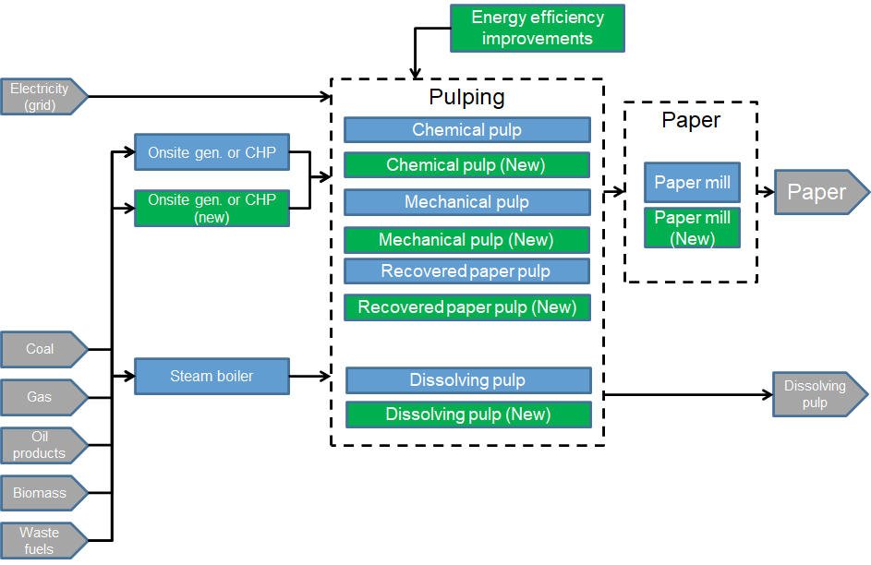

The following energy balance table for the sector is based on energy intensity values for the various technology nodes (such as boilers) originally derived from Napp, and from known sales to the sector in electricity and coal (see energy balance section).

Pulp and Paper energy balance for SATIM for 2017

|  |  |  |  |  |  |  |  |  |
| --- | --- | --- | --- | --- | --- | --- | --- | --- |
|  |  | Coal | Biomass | Gas | Black liquor | HFO | Steam | Elec |
| Plants producing pulp or paper | Chemical (& NSSC) | -3.91 |  |  |  |  | -15.57 | -4.10 |
| Mech (&Thermo) |  |  |  |  |  | -1.51 | -3.32 |
| Dissolving pulp | -2.27 |  |  |  |  | -8.77 | -2.18 |
| Recovered paper |  |  |  |  |  | -1.26 | -0.77 |
| Paper Mill | -1.96 |  |  |  |  | -23.11 | -5.51 |
| Subtotal | -8.14 |  |  |  |  | -50.22 | -15.88 |
| Boilers producing steam | Biomass |  | -3.36 |  |  |  | 2.42 |  |
| Coal | -31.75 |  |  |  |  | 21.88 |  |
| Coal/HFO | -12.01 |  |  |  | -0.44 | 8.67 |  |
| Gas |  |  | -2.02 |  |  | 0.64 |  |
| Black liquor |  |  |  | -41.39 |  | 23.31 |  |
| Subtotal | -43.76 | -3.36 | -2.02 | -41.39 | -0.44 | 56.92 |  |
| CHP |  |  |  |  |  |  | -15.49 | 7.92 |
|  | Total | -51.9 | -3.36 | -2.02 | -41.39 | -0.44 | -22.19 | 23.80 |

**Commercial**

Energy use in the commercial sector includes private and public commercial building energy use, as well as energy use for water treatment and public lighting. The demand for energy in the commercial sector is driven by growth in commercial building floor area, which is driven in turn by increases in commercial GDP. In 2017, the commercial floor area is assumed to total 139 million square meters of which 20% is assumed to be public. Floor area increases to around 156 million square meters in 2030 in the reference case.

Floor area is divided into existing and new floor area, allowing the model to respond to building standards and changes in building design that would, for example allow modern heating or cooling. All buildings built after 2017 are “new” buildings. In addition to increases in commercial floor area “new” building floor area also replaces old building floor area over time. This is done to accommodate cases where older buildings are either demolished or undergo a large retrofit that would allow the buildings to match the energy intensity anticipated in “new” buildings. The figure below shows the increase in floor area over time with 2017 as the index base year. It also shows the decrease in existing floor area from 2017 onwards.

Growth in commercial floor area indexed to 2017

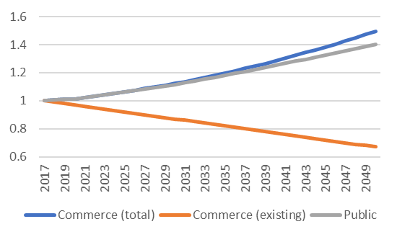

Commercial and public buildings are assumed to have an energy need for space heating and cooling, cooking, lighting, water heating, refrigeration and for “other” uses. The majority of energy is used for cooling and lighting (38.5 and 33.5 percent respectively) and therefore any improvements in energy efficiency in these areas, has a large savings potential.

The total energy use assigned to commerce in 2017 is shown in the table below. The energy consumption assigned to commerce in the GHG inventory is also shown in the table. There is a large difference in diesel use, between the inventory and SATIM. This is largely because SATIM only allocates the use of diesel in buildings to this sector. Commercial use of diesel for transport is included in the transport sector.

Fuel use in the commercial sector

|  |  |  |  |  |  |  |  |
| --- | --- | --- | --- | --- | --- | --- | --- |
| PJ | Coal | Diesel | Electricity | Gas | HFO | Paraffin | LPG |
| NDC Update | 26.66 | 1.50 | 129.04 | 1.23 | 0.23 | 2.56 | 4.03 |
| DEFF inventory | As above | 196.8 |  |  | 20.1 | 0.5 |  |

There has been a large drop in electricity consumption assigned to buildings between 2012 and 2017, from 143TJ to 123TJ. This implies an 18% reduction in the electrical intensity of buildings (MJ/m2) between 2012 and 2017. Over the same period coal use assigned to commerce has increased from 15TJ to 26TJ in 2017 to match the figure used in the Inventory.

The assignment of fuels to building services is shown below. Cooling, lighting and refrigeration are assumed to be met solely with electrical appliances, whereas space heating and water heating are assumed to rely primarily on coal. LPG and natural gas are used only for water heating, space heating and cooking. Energy use for lighting and water treatment is assumed to be 4% of total electricity demand in the sector in 2017.

Fuel use for commercial sector energy services (excludes public water services and public lighting)

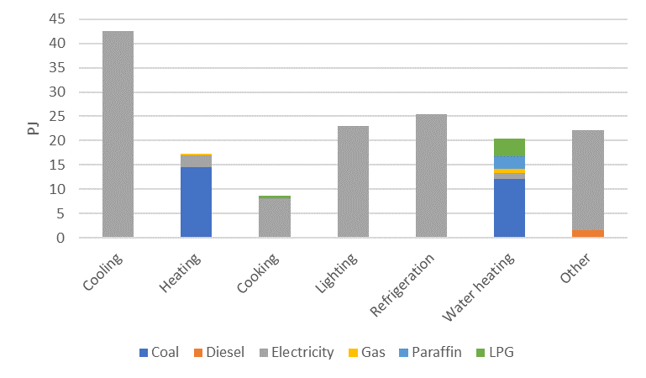

In the reference case, new buildings have the same demand for energy services as the 2017 building stock. This does not mean that the energy intensity remains the same as energy services can be met by more efficient appliances.

**Agricultural energy**

Agricultural energy demand within SATIM has no subsector disaggregation but instead end-use service demand is divided into: Irrigation; Heating; Processing; Traction and Other. The table below details the fractional share of fuel use for each of the end-use activities (Winkler, 2007). Traction specifically refers to off-road activity as road vehicles are captured in the SATIM transport sector. The estimated total energy utilisation by fuel type for agriculture in 2017 is provided below.

End-use fractional shares for agricultural activity (Winkler, 2007)

|  |  |  |  |  |  |  |  |
| --- | --- | --- | --- | --- | --- | --- | --- |
| Fractional Shares | Coal | Diesel | Electricity | Gasoline1 | HFO | Paraffin | LPG |
| Heating | 25.5% | 0.0% | 0.0% | 0.0% | 33.5% | 40.4% | 0.6% |
| Processing | 0.0% | 0.0% | 100.0% | 0.0% | 0.0% | 0.0% | 0.0% |
| Traction | 0.0% | 100.0% | 0.0% | 0.0% | 0.0% | 0.0% | 0.0% |
| Irrigation | 0.0% | 17.8% | 82.2% | 0.0% | 0.0% | 0.0% | 0.0% |
| Other | 0.0% | 0.0% | 100.0% | 0.0% | 0.0% | 0.0% | 0.0% |

*1Gasoline is allocated to the transport sector which captures road vehicles in-use.*

Fuel demand in Agriculture for 2017

|  |  |  |
| --- | --- | --- |
| Fuel | Demand (TJ) | Source |
| Coal | 1,998 | DMRE |
| Electricity | 20,772 | StatsSA (SUT)1 |
| Diesel | 49,181 | UCT from DEA FCS (2016)2 |
| LPG | 45 | UCT from DEA FCS (2016) |
| Paraffin | 3,162 | UCT from DEA FCS (2016) |
| HFO | 2,624 | DEFF FCS (2018) |

*1SUT: Supply and Use Tables (derived from Rand value); 2 Extension of the 2016 DEA fuel consumption study*

No agricultural energy utilisation PAMS are modelled. Energy utilisation toward 2030, distinct from the AFOLU measures which are included in section 8.3 are considered to be of negligible consequence given the sector’s present share of energy demand in the national account (DMRE, 2017).

**Refineries**

Liquid fuel production by domestic refineries are modelled in SATIM at the aggregate process level. That is, key energy commodities such as crude oil, coal, gas and electricity as feedstock are transformed into energy products such as gasoline, diesel, jet fuel, paraffin and LPG for end-use. Process emissions factors as listed below are calculated in terms of the energy content of the product slate per refinery type where the coastal refineries are presently grouped as a single process. Production, imports and exports of liquid fuels is matched to SAPIA data.

Refinery Process Emissions Factors used in SATIM

|  |  |  |  |
| --- | --- | --- | --- |
| Facility | Process emission factor CO2 (kt/PJout) | Process emission factor CH4 (kt/PJout) | Key Data Source |
| CTL (Secunda) | 99.5 | 0.397 | Sasol |
| Inland Crude Refinery | 4.76 | 0 | Sasol |
| Coastal Refineries | 4.29 | 0 | SAPIA |
| GTL | 6.49 | 0.0045 | PetroSA; DEFF |

*Coal-to-Liquids (CTL)*

Emissions from the CTL are calibrated to match the NIR 2017 submission by SASOL (2018). The SATIM model has a disaggregated representation of the CTL complex in which commodities such as coal and natural gas are transformed into a product slate comprising a detailed energy commodity slate (e.g. petrol, diesel & jet fuel) and aggregated non-energy products. Coal and gas are prime feedstock commodities which are split into four main activities, namely: material use for the Fischer-Tropsch (FT) process; steam generation for the FT process; steam generation for general process use; and ; steam generation for onsite electricity production. The commodity usage is based on the SASOL submission summarised below. This data is cross referenced with other published data to balance the commodity usage by activity (Bultitude 2013; NERSA 2018, SASOL 2018a,b; Sasol 2019a,b,c,d; Sasol 2017). A process emissions factor (IPPC 1B3) is derived from the balance of emissions reported by Sasol for its facilities (Sasol 2019b).

2017 SASOL GHG inventory as applied in SATIM calibration, tonnes/year

|  |  |  |  |
| --- | --- | --- | --- |
| IPCC category | CO2 | CH4 | N20 |
| 1A | 28,478,205 | 360 | 456 |
| 1B | 25,578,843 | 9,888 | - |
| 2B | 241,415 | 7,962 | 692 |
| 4D | 188,027 | 3,853 | - |
| Total | 54,486,490 | 112,063 | 1,148 |

*Source (Sasol, 2018a)*

*Crude-Oil*

As per CTL, Crude oil refineries are modelled similarly with electricity and crude oil key feedstock commodities. A process emissions factor, specified in terms of product output for the inland crude oil refinery, Natref, is derived from Sasol submission data (Sasol 2019c). SAPIA (2018) is the main source for refinery production and emissions data for the remaining refineries. The product slate for the refineries is based on the comprehensive assessment conducted by Lloyd (2001).

*Gas-to-Liquids (GTL)*

Production (activity) data - published by PetroSA (2007; 2012; 2018; 2019) in conjunction with activity data provided in the NIR 2017 is the basis for the emissions factor derivation.

**Gas Supply**

Domestic gas supply for the year 2017 is derived from PetroSA (2018) and importation via Sasol (2017). PetroSA reports production of 24.7 Bscf (~26,765 TJ at LHV) compared to the DMRE 2017 value of 25,838 TJ. Gas supply from Sasol is illustrated below.

Gas mass balance for SASOL’s gas supply (Sasol 2017)

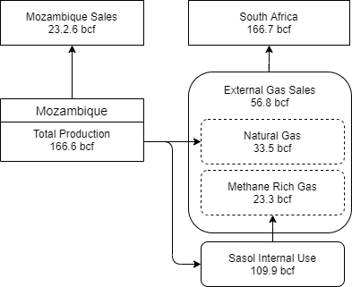

*Fugitive emissions*

Methane (CH4) as a fugitive emissions GHG is included in SATIM for transport, storage and distribution of gas. A constant EF of 0.07 ktCH4/PJout (0.0972 gCH4/MJ) as derived by Skone et al. (2011) (after DEA (2014b)) is applied for all sectors. We assume that there is an unintentional leakage of 1% of gas activity from the natural gas system, noting that for a proper accounting, the percentage of emissions that emanate from operations such as the movement of trucks, compressor stations, etc is necessary to improve the modelling of fugitive emissions.

**Appendix D: Energy efficiency PAMS**

For the CPAMS-CAP*xx* scenarios only demand side PAMS are included. These are focused in the Transport, Residential, Commercial and Industrial sectors as per the 2015 National Energy Efficiency Strategy (NEES).

**Transport**

The modelling analyses presumes, conservatively, that all scenarios experience an annual vehicle fuel efficiency improvement of 0.5% and 0.1% for public and freight road vehicles, respectively, as is modelled in the Integrated Energy Plan (DoE, 2016).

## Residential

Policies and measures applied in the residential sector have the effect of increasing the efficiency at which energy services are delivered in the sector. There are two primary mechanisms for achieving this, firstly through increasing appliance efficiency and secondly through the introduction of building standards which reduce the need for energy to supply space heating, lighting, and water heating. NEES targets in this sector call for a 33% reduction in the average specific energy consumption of new household appliances purchased in South Africa between 2015 and 2030. A 20% reduction in the average energy performance of the residential building stock between 2015 and 2030, which is achieved through a combined target of 15% improvement in the thermal performance of buildings built before 2015 and a 38% average improvement in the energy performance of new buildings. These improvements are then assumed to persist until 2050.

The mechanisms for achieving savings in this sector are mandatory building standards, mandatory appliance standards and a mandatory appliance labelling programme aimed at driving the purchase of more efficient appliances. Building standards (SANS 204) dictate a maximum energy demand based on building type and climatic zone and encourage passive building design. In 2008, the SABS began the adoption of the IEC 941 standard as SANS 941 for the energy efficiency of electrical and electronic apparatus. In November 2014, government gazetted compulsory specifications for minimum energy efficiency performance and labelling covering twelve appliance types (VC9008).

There is currently little information to gauge the extent to which building standards, the MEPS and S&L programmes have already impacted energy demand in the sector. Information relating to the degree to which building standards may be impacting consumption is particularly scarce. However, as the standards are in place, the reference case, high and low scenario all assume a reduction in useful energy demand and an increase in appliance efficiency over time. The policy impact assumed for the high and low cases is shown in the table below. Efficiency improvements are assumed to impact appliance efficiency in all income groups, whereas housing standards only impact energy needs in the middle- and high-income groups.

## Residential sector PAMS

|  |  |  |
| --- | --- | --- |
| Average specific energy consumption of household appliances | Standards increase the efficiency of refrigeration and other electrical energy services within the model. The efficiency of cooking with coal and wood is also increased. | Assumes that the target of 33% is reached |
| Energy performance of building stock | Building design efficiency improvements are modelled by reducing the useful energy demand for lighting, space heating and cooling | Assumes that the target of 20% is reached |

## Commerce

The post 2015 NEES aims to improve the efficiency at which energy services are delivered in buildings through refurbishment of older buildings and the successive tightening of building standards for new buildings. It also aims to improve the efficiency at which municipal services are delivered. The buildings standard (SANS 2014:2011) should reduce the energy needed for lighting, heating, water heating, space heating and HVAC. In addition, the minimum energy performance standards (MEPS) will improve the efficiency of appliances. In addition to these two mechanisms, energy endorsement labels for appliances and energy performance certificates for buildings could be implemented.

The post 2015 NEES includes a target of 37 percent reduction in the specific energy consumption (SEC) (measured as GJ annual energy consumption per m2 of lettable/habitable floor area) based on reducing the average SEC of building built before 2015 by 20 percent between 2015 and 2030, and a 54 percent lower average SEC for buildings built after 2015 by 2030. For public buildings, the target is a 50 percent reduction in SEC between 2015 and 2030 (measured as GJ annual energy consumption per m2 of occupied floor area). Which is based on lowering the SEC for buildings built before 2015 by 35% and lowering the SEC of new buildings by 58 percent. These improvements persist until 2050.

Targets for municipal service delivery aim for a 20 percent reduction in the energy intensity of municipal service provision (measured as energy consumption per capita of population served). The services included are street lighting, traffic lights, water supply and wastewater treatment.

## Commercial sector PAMS

|  |  |  |
| --- | --- | --- |
| Commercial buildings specific energy consumption | Standards increase building stock efficiency - this is included in the model by assuming a reduction in the intensity of energy services required in each building. | Assumes the target of 37% reduction in the SEC is achieved by 2030 compared to 2015 |
| Public buildings specific energy consumption | The efficiency at which energy services are delivered increases, this is included in the model by assuming a reduction in the intensity of energy services required in each building. | Assumes the target of 50% reduction in the SEC is achieved |
| Municipal services | Only the improvement in the intensity of street lighting and water supply is modelled | Assumes the target of 20 % improvement in efficiency |

## Industry

The NEES post 2015 is the overarching energy efficiency strategy applicable to the industrial, manufacturing, and mining sectors. The NEES aims primarily at reducing electricity consumption, with little mention of thermal fuel efficiency. The NEES targets for industry and their implementation in SATIM and the PAMS scenarios are presented below.

Industry PAMS

|  |  |  |
| --- | --- | --- |
| Mining | The NEES indicated a cumulative energy saving of 40 PJ by 2030 in mining. Given that NEES post 2015 document was published some time ago already, and that electricity prices have been rising over the years, it is assumed some EE measures have been implemented already since the NEES document came out. It is assumed that 25% of this target has been reached intrinsically through the actions of industries since 2015 and the remaining cumulative savings of 30PJ from 2020 to 2030 remains the target. This target results in an estimated 3% saving by 2025, and 4% savings by 2030 based on SATIM projections for this sector.  In SATIM, these measures were implemented by improving the efficiency of all electrical end-use services (lighting, pumping, compressed air, and the main energy consumer – electrical motors) for those years – 2020 through to 2030. These measures are assumed to remain constant to 2050. | The necessary investments associated with these improvements are not included explicitly in the CGE model. Rather, it is assumed that the standard investments made by this sector include those to improve efficiencies. |
| Manu-facturing | The NEES indicates a 35% improvement in energy services in the industry (excluding furnaces and kilns), and only a 5% improvement in furnaces and kilns.  These measures are implemented in SATIM by improving the efficiency of all technologies supplying end-use services for manufacturing, food and beverages, other precious and non-ferrous metals (excl. aluminium), and chemicals industrial sectors. For lighting, HVAC, compressed air, motors, and pumps, the efficiencies are improved by 35% by 2030.  The efficiencies for kilns in the cement, lime, glass industries, and blast furnaces and arc furnaces in the steel, ferroalloys and non-ferrous metals industries are improved by 5% by 2030. | Steel and cement industries are modelled in SATIM with technology stock – i.e. existing stock that may be replaced by new stock. The new stock does not benefit from efficiency gains mentioned here.  The necessary investments associated with these improvements are not explicitly included in the CGE model. Rather, it is assumed that the standard investments made by this sector include those to improve efficiencies. |

**Appendix E: Other PAMS (excl. energy efficiency)**

The energy PAMS included in the CPAMS scenarios are outlined below and include the demand side PAMS discussed in Appendix D.

## Power

Integrated Resource Plan (IRP): A revised version of the 2019 IRP, which uses the same investment schedule as the 2019 IRP, with adjustments for lead times for plants coming onto the system is included.

The plan as stated is based on several assumptions which are already outdated, which will be adjusted for modelling the IRP in this context. These are:

* Demand projections in the IRP 2019, especially considering load shedding and the impact that the ratings downgrade and the COVID-19 crisis is having on the South African economy, are overestimated in the 2020s. Electricity demand for 2019 was below the lowest projected demand scenario in IRP 2019, and will be even lower in 2020. SATIM-ESAGE calculates demand endogenously and is driven primarily by the economic growth rate. As a result, the IRP is modelled with a lower electricitydemand than is assumed in the IRP. Assuming the implementation of energy efficiency policies will further lower demand.
* The energy availability factors (EAF) of Eskom’s existing fleet is assumed to follow what is in the IRP, in that the weighted average for coal plants is 67.7% in 2020, rises to 72.5% in 2025 and remains stable at that level until 2031. (Note that in the draft results slightly lower values were assumed 65% in 2020, 70% in 2025 and 71% in 2030).
* The dates at which new capacity is due to come online are overoptimistic for new coal plants, wind plants and gas plants. These dates have been moved back after consultation with experts.
* Retirement of existing Eskom coal plants will be modelled according to the schedule contained in the IRP, with Eskom reported shutdowns of older stations incorporated.
* In terms of the application of minimum emissions standards, in the light of Eskom’s applications for alternative standards and consultations with DEFF, it will be assumed for both scenarios that FGD will be operational at Kusile as units come online, and that FGD will be retrofitted at Matimba, Kendal and Medupi by 2030. It will also be assumed for all scenarios that Koeberg nuclear power plant’s life will be extended in 2024 for another 20 years as per IRP 2019.
* Since there is uncertainty re the technology characteristics of the new coal capacity in the IRP, two plants will be modelled – one 750 MW FBC plant with the characteristics of the plant currently proposed for Thabametsi, and one 750 MW supercritical plant, in conformance with the specification that new coal plants should be HELE plants. It is assumed that the FBC technology will involve sulphur removal during the combustion process, and that FGD will be included in the design of the supercritical plant.

Electricity sector summary

|  |  |
| --- | --- |
| Expansion plan | As per IRP, revised on assessment of necessary lead times. |
| Limits to annual technology build rates | As per IRP. |
| Retirement schedule | As planned in IRP 2019, updated as per any Eskom reporting re retiring units. |
| New Coal | 1500 MW of New Coal before 2030; one FBC plant, one supercritical plant with FGD; timing of first plant moved back to conform with realistic lead times. |
| Distributed generation | draft Determination of 2000 MW/ year commissioned in the short term; thereafter 500 MW/year as in the IRP |
| MES implementation | FGD assumed to be installed on Medupi, Kusile, Matimba and Kendal by 2030, and on any new coal plants. |

## Details of the power sector build limits

|  |  |  |  |  |  |  |  |  |  |
| --- | --- | --- | --- | --- | --- | --- | --- | --- | --- |
|  | 2022 | 2023 | 2024-25 | 2026-27 | 2027 | 2028-29 | 2030 | 2031-32 | 2033 |
| Rooftop Solar PV |  |  |  |  |  |  |  |  |  |
| commerce | 0.315 | 0.35 | 0.3 | 0.25 | 0.225 | 0.2 | 0.2 |  |  |
| industrial | 0.09 | 0.1 | 0.15 | 0.2 | 0.225 | 0.25 | 0.25 |  |  |
| residential | 0.045 | 0.05 | 0.05 | 0.05 | 0.05 | 0.05 | 0.05 |  |  |
| Solar PV | 1.4 | 1 |  |  |  | 1 | 1 |  |  |
| Wind | 0.818 | 0.8 | 1.6 | 1.6 | 1.6 | 1.6 | 1.6 | 1.6 | 0.8 |
| FBC |  |  |  | 0.75 | 0.75 |  |  |  |  |
| Grand Inga |  |  |  |  |  |  | 1.5 |  |  |
| LNG – CCGT |  |  |  |  | 1 |  |  |  |  |
| LNG - OCGT |  |  |  | 1 | 1 |  |  |  |  |

Power Sector IRP fixed capacity additions (GW/year)

|  |  |  |  |  |  |  |  |
| --- | --- | --- | --- | --- | --- | --- | --- |
|  | 2023 | 2024 | 2025 | 2026 | 2027 | 2028-30 | 2031-35 |
| Rooftop - Commerce | 0.35 | 0.3 | 0.3 | 0.25 | 0.225 | 0.2 |  |
| Rooftop - Industrial | 0.1 | 0.15 | 0.15 | 0.2 | 0.225 | 0.25 |  |
| Rooftop - Residential | 0.05 | 0.05 | 0.05 | 0.05 | 0.05 | 0.05 |  |
| Solar PV | 0.5 | 0.6 | 0.7 | 0.8 | 0.9 | 1 | 1 |
| Wind | 0.8 | 0.9 | 1 | 1.2 | 1.4 | 1.6 | 1.6 |

## Transport

The Green Transport Strategy (GTS) consists of 10 strategic pillars with 6 short-term strategic targets. These pillars and measures provide objectives for the transport sector but do not necessarily indicate how these will be achieved or specify targets or deadline for achieving them. For this reason, the measures modelled primarily include those related to land transport which have sufficient information to be quantitatively assessed and/or can be further defined using other stated government targets.

The scenarios modelled are summarised and explained in more detail below:

* Shift of freight transport from road to rail
* Shift of passenger transport from private cars to public transport and eco-mobility transport
* Promote alternative fuels such as compressed natural gas (CNG) or biogas, and liquid biofuels as transport fuels
* Promote electric and hybrid-electric vehicles

The way each of these scenarios are modelled is discussed below.

* Migrate road freight to a rail alternative within 7 years. The DEA (2014) freight road to rail report indicates aspirational shares of 30%, 50% and 70% for corridor rail activity by 2045 with the 30% and 70% shares suggested as low and high targets respectively. These targets are adopted in this study in line with the NAMAs.
* 20% shift of passenger transport from private cars to public transport and non-motorised transport within 7 years. The shift is based on the GHG Mitigation Potential Analysis (DEA, 2014) which draws upon the Western Cape Infrastructure Framework study (PDG, 2013). Therefore, a shift to public transport approach is modelled with emphasis on public rail and BRT as suggested in the Western Cape study.
* To convert 5% of the public and national sector fleet in the first seven years of the implementation of this strategy and an annual increase of 2% thereafter, to cleaner alternative fuel and efficient technology vehicles. Public sector passenger vehicles comprise less than 1% of the national vehicle parc while the size of public sector freight road vehicles is unknown. Therefore, the national vehicle population is used to gauge the share of alternative vehicle technologies shares.
* Foster a conducive environment for the conversion of public and quasi-public transport vehicles to be converted to dual-fuel vehicles within 10 years.
  + (MiniBus to Bifuel) Presently trialled in Gauteng, the presumption is that bi-fuel vehicles are referred to and apply only to minibus taxis only as alluded to in the GTS 2018. The bi-fuel system comprising natural gas and petrol.
  + (Metro-Bus to Gas) The term “metro-bus” is presumed to refer to bus fleets in urban regions used for public transport purposes. Since there is no data to delineate buses operating in areas which have the potential for natural gas reticulation, the proportion of the national passenger bus fleet which could be converted to CNG is based on an estimation of urban/rural pkm derived from the published national estimates of current and future rural-urban population shares (STATSSA 2019; ADB 2018, WB 2020).

## Transport sector policies and measures

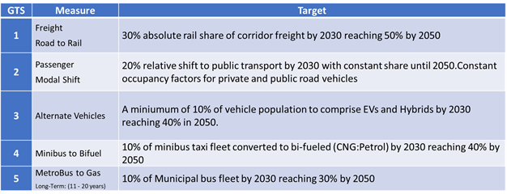

The GTS measure promoting the use of liquid biofuels is included and currently implemented from 2030. The draft Position Paper on the South African Biofuels Regulatory Framework (2014) stipulates a minimum of 2% blending of bioethanol and 5% blending of biodiesel with petrol and diesel respectively. Although initial production was anticipated in 2020, stakeholder feedback in the previous PAMS study resulted in a decision that liquid biofuels blending be included in SATIM as a policy measure from 2030. The minimum blending requirements are included with no upper limit for biodiesel. Higher bioethanol blends require vehicle modification and the model therefore includes e85 vehicles to gauge demand for higher blended bioethanol ratios (>10%/vol). Feedstocks represented in the model are Biodiesel: Canola oil and soya beans; and Bioethanol: Grain sorghum, sugar beet (production is limited to the capacity specified for the facility planned for Craddock (DoE 2014)) and sugarcane.

## Liquid fuels

Crude oil refineries are presumed to continue operating until 2050. SATIM allows for the refurbishment or retirement of crude-oil refineries commencing in 2030.. Capex is estimated at $3.7 billion for fuel complying with the Euro 5 emissions standard at ±40% accuracy (DoE, 2011). In addition, an emissions penalty of ~0.003 t CO2/bbl is associated with the fuel improvement (SAPIA, 2018).

## Carbon Tax

This PAM measures the impact of the Carbon Tax Act No 15 of 2019 (gazetted on 23 May 2019) which has been in effect since 1 June 2019. The tax is modelled as presented in the Act although where no or insufficient information is provided, particularly in relation to phase 2 of the tax, assumptions are made.

As per the Carbon Tax act, the first phase of the carbon tax is in place from the 1 June 2019 to the 31 December 2022. During this period the tax includes scope 1 emitters only and is implemented at a level of R120 per ton of CO2-eq. The first phase of the tax however provides exemptions to sectors, ranging between a cumulative 60% to 95% depending on the sector and the exemption for which it qualifies. Provision for the following exemptions are made: Basic tax-free for fossil fuel combustion/process; Fugitive; Trade exposure; Performance; Carbon budget; Offsets. Given the uncertainty to which companies will apply for various exemptions, we assume a flat 75% exemption rate in each of the scenarios. As a result an effective carbon tax of R20.96 (2019 Rands) is implemented for the 6 months of 2019 rising by 2% per annum in real terms to 2022. During the second phase of the tax (2023-2030), the rate is kept constant and exemptions remain in place.

The tax is implemented across all sectors except those mentioned for exclusion, namely the waste and AFOLU sectors. It is also assumed that none of the installations in the residential, commerce and agriculture sectors meet the threshold as outlined in the Carbon Tax Act. For this reason no carbon tax is imposed on the sectors. During the first phase of the Carbon Tax, the electricity sector is covered by the electricity levy, which is built into the current price of production to 2022. Thereafter the carbon tax is applied as for all other sectors.

The Carbon Tax Act highlights that the tax is levied and collected for the National Revenue Fund with no specific revenue recycling measures identified. For this reason we assume in the revenues form part of the national revenues.

**Appendices References**

ADB (African Development Bank). 2018. Rural population. South Africa. https://dataportal.opendataforafrica.org/axdbnif/rural-population?lang=en

Ahjum, F., Merven, B., Stone, A. and Caetano, T. 2018. Road transport vehicles in South Africa towards 2050: Factors influencing technology choice and implications for fuel supply. Journal of Energy in Southern Africa. https://doi.org/10.17159/2413- 3051/2018/v29i3a5596

Bultitude, D. 2013a. Historical gas usage at Sasolburg and Secunda by activity for the period 2004-2012. Pers comms.

Bultitude, D. 2013b. Technical Life of the CTL facility at Secunda. Pers comms.

CBASA (Claybrick association of Southern Africa). 2016. Life cycle assesment of clay brick walling volume 1 and 2. https://www.claybrick.org/lca-life-cycle-assessment-clay-brick-walling-south-africa

DEA (Department of Environmental Affairs). 2014. Freight Shift from Road to Rail: The Socio-Economic Impact of a Modal Shift Of Freight From Road To Rail To Achieve Maximum Greenhouse Gas Mitigation In The Transport Sector. South Africa. https://www.environment.gov.za/sites/default/files/docs/publications/freightshift_roadtorail.pdf

DEA (Department of Environmental Affairs). 2014b. Greenhouse Gas Emissions Associated with Shale Gas. South Africa. https://www.environment.gov.za/sites/default/files/docs/greenhousegasemissions_associated_withshalegas.pdf

DEA (Department of Environmental Affairs). 2018. Phase II Survey on economy-wide fuel consumption with emphasis on demand-side sectors for the period 2013 – 2018 and Estimation of Vehicle Kilometres Travelled (VKT) for the period 2000 – 2018 and projections to 2035. South Africa.

DEFF (Department of Environment, Forestry and Fisheries). 2020. Draft Strategic approach towards the management and enhancement of carbon sinks in the agriculture, forestry and other land-use (AFOLU) sector in South Africa. Department of Environment, Forestry and Fisheries. Pretoria, South Africa.

DEFF (Department of Environment, Forestry and Fisheries). 2020b. Draft National GHG Inventory Report for 2000 – 2017. Department of Environment, Forestry and Fisheries, Pretoria, South Africa.

DMR (Department of Mineral Resources). 2019. South African Mineral Industry 2017-2018.

Diao X, Thurlow J. 2012. A recursive dynamic computable general equilibrium model. In: Diao X, Thurlow J, Benin S, Fan S, editors. Strategies and priorities for African agriculture: economywide perspectives from country studies. Washington DC, USA: International Food Policy Research Institute.

DMRE (Department of Mineral Resources and Energy). 2017. Energy Statistics. http://www.energy.gov.za/files/energyStats_frame.html

DMRE (Department of Mineral Resources and Energy). 2018. Liquid fuels by magisterial district by trade category 1998-2018. Pretoria, South Africa.

DoE (Department of Energy). 2011. Discussion Document on the Review of Fuel Specifications and Standards for South Africa (edited). Government Gazette No. 34089. South Africa. http://www.energy.gov.za/files/esources/petroleum/March%202011/1-34089%208-3%20Energy.pdf

DoE (Department of Energy). 2014. Draft position on the South African biofuels regulatory framework. Government Gazette No. 37232. South Africa.

DoE REDIS (Department of Energy). 2018. Renewable Energy Data and Information Service. http://redis.energy.gov.za/national/

EIA (Energy Information Agency). Manufacturing Energy Consumption Survey (MECS). https://www.eia.gov/

EPRI (Electric Power Research Institute). 2017. Power Generation Technology Data for Integrated Resource Plan of South Africa: Technical update, April 2017. EPRI, Palo Alto, CA: 2017.

Eskom. 2018. Fuel consumption data 2010-2018. http://www.eskom.co.za/OurCompany/SustainableDevelopment/Pages/CDM_Calculations.aspx

Eskom. 2019. Shutdown of Grootvlei, Komati & Hendrina Power Stations. GGF presentation, 25/04/2019.

EU Commission [European Union Commission]. 2010. Reference Document on the best available techniques in the cement, lime, and MgO manufacturing industries.

Hibberd, A. 1996. Energy efficiency in the South African clay brick industry. University of Cape Town, South Africa.

International Energy Agency (IEA). 2010. IEA-ETSAP Technology Brief I02, May 2010. www.etsap.org

International Energy Agency (IEA). 2019. The Future of Hydrogen. https://www.iea.org/reports/the-future-of-hydrogen

Ireland, G. and Burton, J. 2018. An assessment of new coal plants in South Africa’s electricity future: the cost, emissions, and supply security implications of the coal IPP programme. Energy Research Centre - University of Cape Town, South Africa.

Lagendijk, H., Xakalashe, B., Ligege, T., Ntikang, P. and Bisaka, K. 2010. Twelfth international Ferroalloys congress. http://www.mintek.co.za/Pyromet/Files/2010Lagendijk.pdf

Lloyd, PJD. 2001. The South African Petroleum Industry: A Review, Energy Research Institute, University of Cape Town, South Africa.

Lofgren H, Harris RL and Robinson S. 2002. A standard computable general equilibrium (CGE) model in GAMS. Washington DC, USA: International Food Policy Research Institute.

Merven, B., Stone, A., Hughes, A. and Cohen, B. 2012. Quantifying the energy needs of the transport sector for South Africa: A bottom-up model. Energy Research Centre, University of Cape Town, South Africa. http://www.erc.uct.ac.za/sites/default/files/image_tool/images/119/Papers-2012/12-Mervenetal_Quantifying_energy_needs_transport%20sector.pdf

National Treasury. 2020. Supplementary Budget. Pretoria, South Africa http://www.treasury.gov.za/documents/National%20Budget/2020S/

NERSA (National Energy Regulator of South Africa). 2018. Electricity Generation Statistics by Licensee. Pretoria, South Africa

PetroSA (Petroleum Agency South Africa). 2007. Integrated Annual Report. http://www.petrosa.co.za/discover_petroSA/Pages/Investor-Centre.aspx

PetroSA (Petroleum Agency South Africa). 2012. Integrated Annual Report. http://www.petrosa.co.za/discover_petroSA/Pages/Investor-Centre.aspx

PetroSA (Petroleum Agency South Africa). 2018. Integrated Annual Report. http://www.petrosa.co.za/discover_petroSA/Pages/Investor-Centre.aspx

PetroSA (Petroleum Agency South Africa). 2019. Integrated Annual Report. http://www.petrosa.co.za/discover_petroSA/Pages/Investor-Centre.aspx

SAPIA (South African Petroleum Industry Association). 2018. Crude oil refinery emissions resultant from the Cleaner Fuels Phase 2 implementation. Pers Comms. South Africa

Sasol. 2017. Additional Analyst Information. https://www.sasol.com/sites/default/files/financial_reports/Additional%20Analyst%20Information%20-%2031%20December%202017.pdf

Sasol. 2018a. Annual Emission Report, Annexure 1: Sasol’s 2017 GHG submission to the national GHG reporting regulations. South Africa.

Sasol. 2018b. Sustainability Report. https://www.sasol.com/investor-centre/financial-reporting/sustainable-development-report/latest

Sasol. 2019a. Additional Analyst Information. https://www.sasol.com/investor-centre/financial-reporting/financial-results-and-analyst-book/latest

Sasol. 2019b. Climate Change Report. https://www.sasol.com/investor-centre/financial-reporting/sustainable-development-report/latest

Sasol. 2019c. Business Performance Metrics. https://www.sasol.com/investor-centre/financial-reporting/business-performance-metrics

Sasol. 2019d. A Sasol perspective on sustainability and power fuels. https://www.powerfuels.org/test/user_upload/4_Attach_1_-_20191209_Sasol_Powerfuels_Presentation_09-Dec-2019_rev3.pdf

Scholtz, V., Magudulela, D.S., van Zyl, F., Coetzee, A., Humpel, A., Hill, C. and Potgieter, A.J. 2006. Added Value Long Steel Products produced at MSSA Newcastle Works, Southern African Pyrometallurgy.

Skone TJ., Littlefield J., Marriott J. 2011. Life cycle greenhouse gas inventory of natural gas extraction, delivery and electricity production. Final report 24 Oct 2011 (DOE/NETL-2011/1522). U.S. Department of Energy, National Energy Technology Laboratory, Pittsburgh, USA.

StatsSA. Supply and Use Tables. http://www.statssa.gov.za/

Steyn, G., Burton, J. and Steenkamp, M. 2017. Eskom’s Financial Crisis and the Viability of Coal-Fired Power in South Africa: Implications for Kusile and the Older Coal-Fired Power Stations. Cape Town: Meridian Economic.

Stone, A., Merven, B., Maseela, T. and Moonsamy, R. 2018. Providing a foundation for road transport energy demand analysis: The development of a vehicle parc model for South Africa. Journal of Energy in Southern Africa 29(2): 29-42. https://doi.org/10.17159/2413-3051/2018/v29i2a2774

Transnet. 2019. Integrated Report. Transnet. South Africa. http://transnet-ir-2019.co.za/

Vogl, V., Åhman, M. and Nilsson, L.J. 2018. Assessment of hydrogen direct reduction for fossil-free steelmaking, Journal of Cleaner Production.

WB (World Bank). 2020. Rural population (% of total population). https://data.worldbank.org/indicator/SP.RUR.TOTL.ZS?end=2019&locations=ZA&start=1960&view=chart

Winkler, H. (ed) 2007. Long Term Mitigation Scenarios: Technical Report. Prepared by the Energy Research Centre for Department of Environment Affairs and Tourism, Pretoria, South Africa.

Worrell, Ernst & Martin, Nathan & Price, Lynn. 2000. Potentials for Energy Efficiency Improvement in the US Cement Industry. Energy. 25. 1189-1214. 10.1016/S0360-5442(00)00042-6.

Worrell, E., Price, L., Martin, N., Hendriks, C. and Ozawa-Meida, L. 2001. Carbon Dioxide Emission from the Global Cement Industry. Annu. Rev. Energy Environ. 26. 303-29.

Worrell, E., Price, L., Neelis, M., Galitsky, C., Nan, Z. and Lawrence, E. 2008. World Best Practice Energy Intensity Values for Selected Industrial Sectors.

1. NAAMSA = National Association of Automobile Manufacturers of South Africa, eNaTIS = electronic NationalAdministration Traffic Information System, SAPIA = South African Petroleum Industry Association, NatMap =National Transport Master Plan, SOL = State of Logistics Survey for South Africa, EB = National Energy Supply and Demand Balance, Department of Energy
2. A large portion of the Methodology 2 sector industries for SATIM were first characterised by Dr. Tamaryn Napp, a visiting post-doctoral researcher from Imperial College London. She interviewed many local industry stakeholders in the heavy industries of South Africa and collated much of the literature used for these industrial sector representations. Some of the texts in these sections are based on her notes and documents.